**Grocery Store**

**ER Diagrams**

User

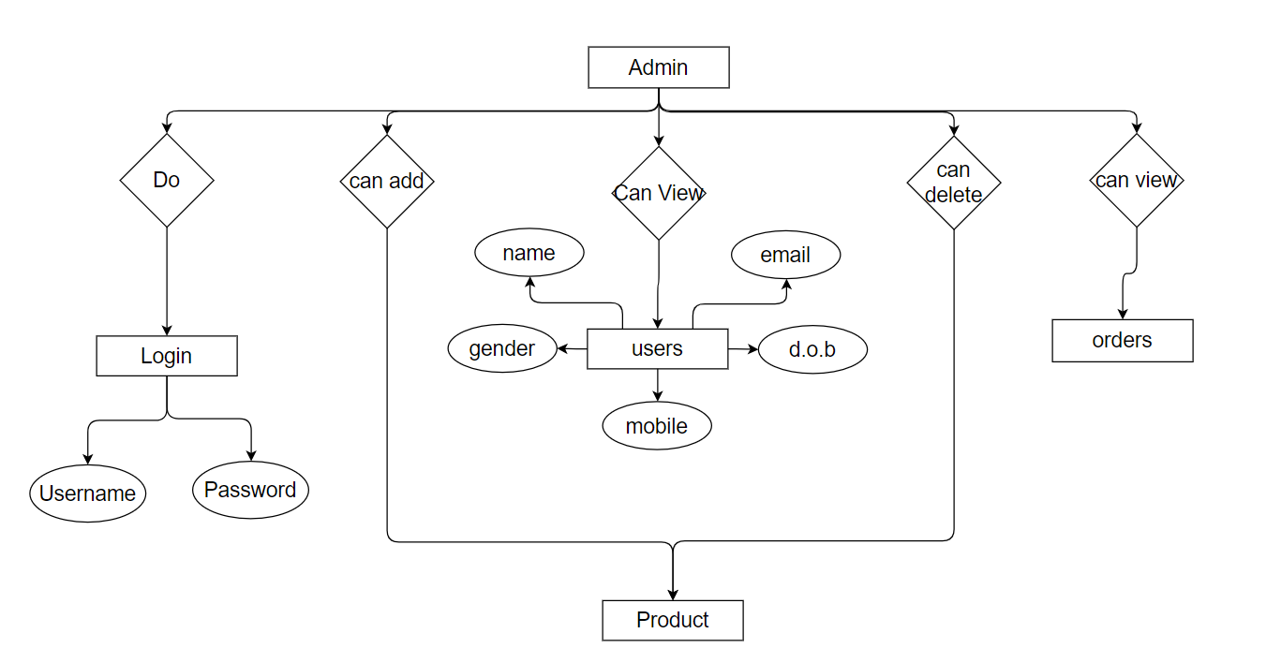Admin

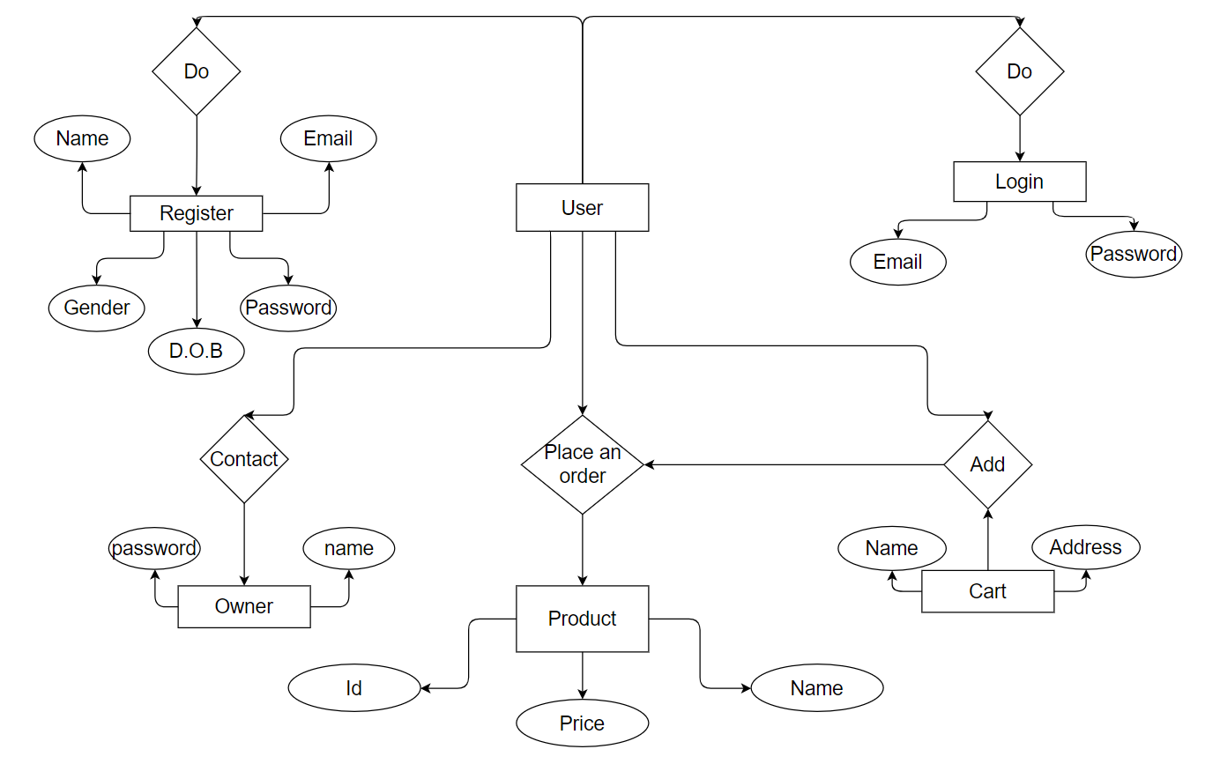

**DFD (Data Flow Diagram)**

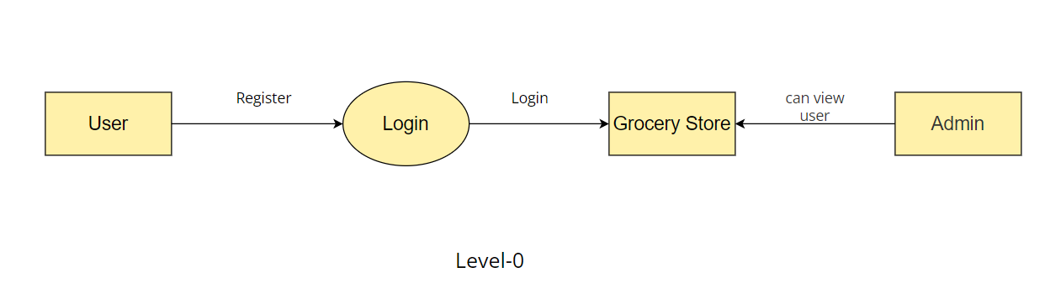Level : 0

Level : 1

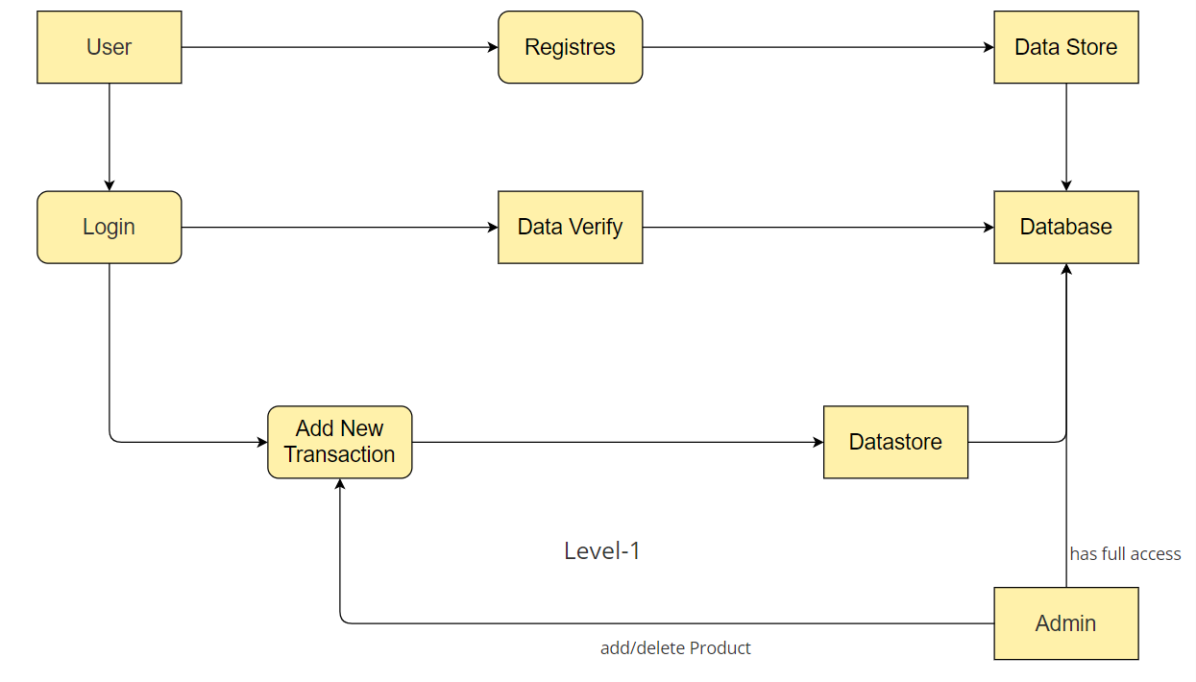

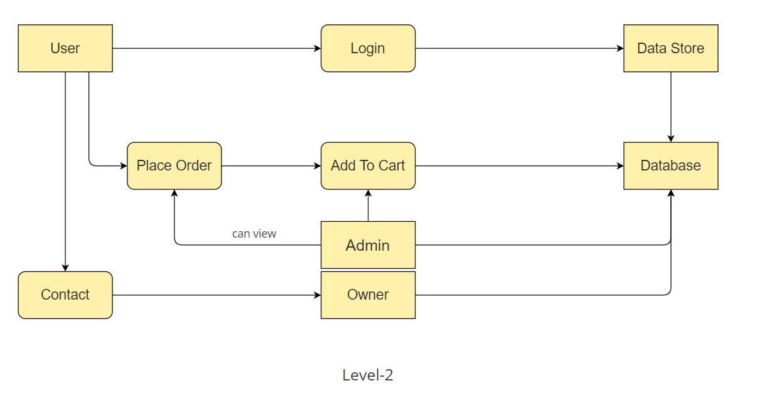Level : 2

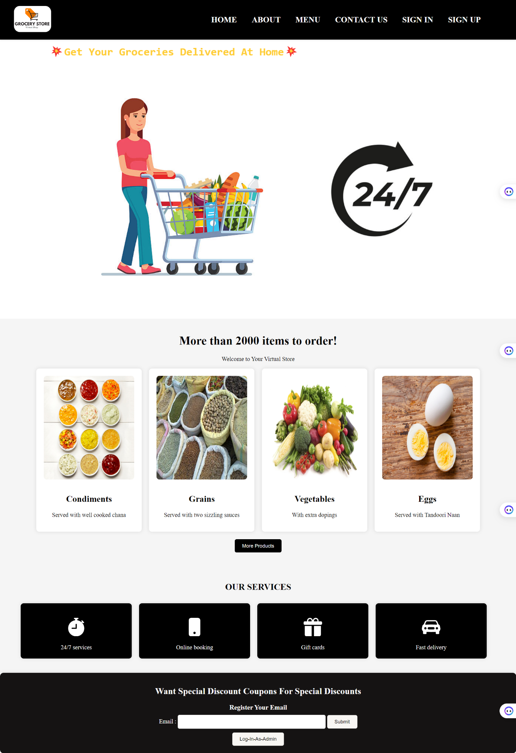**Website Snapshots**

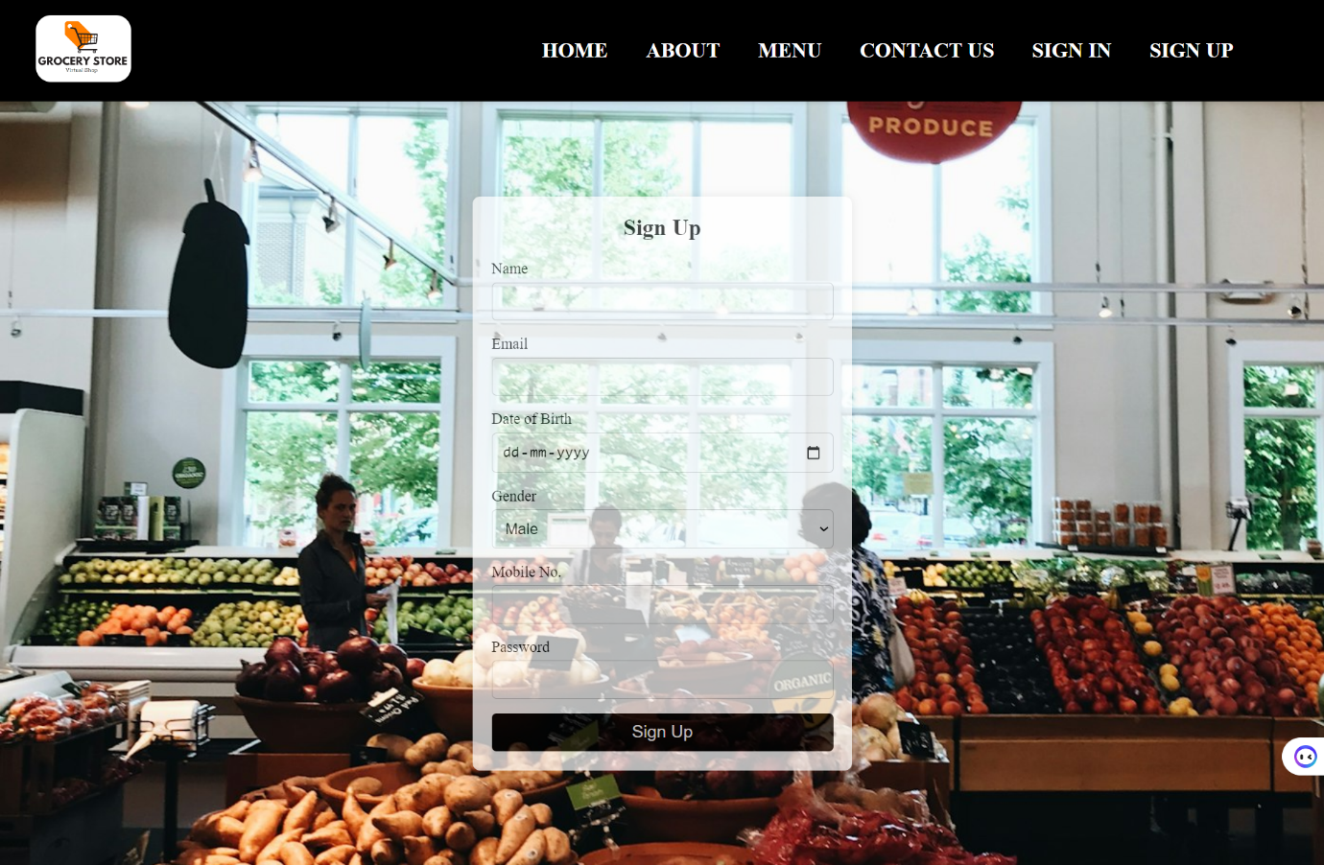This is the first page of website representing with header and footer and in header various items are placed and when being clicked redirects to desired pages.

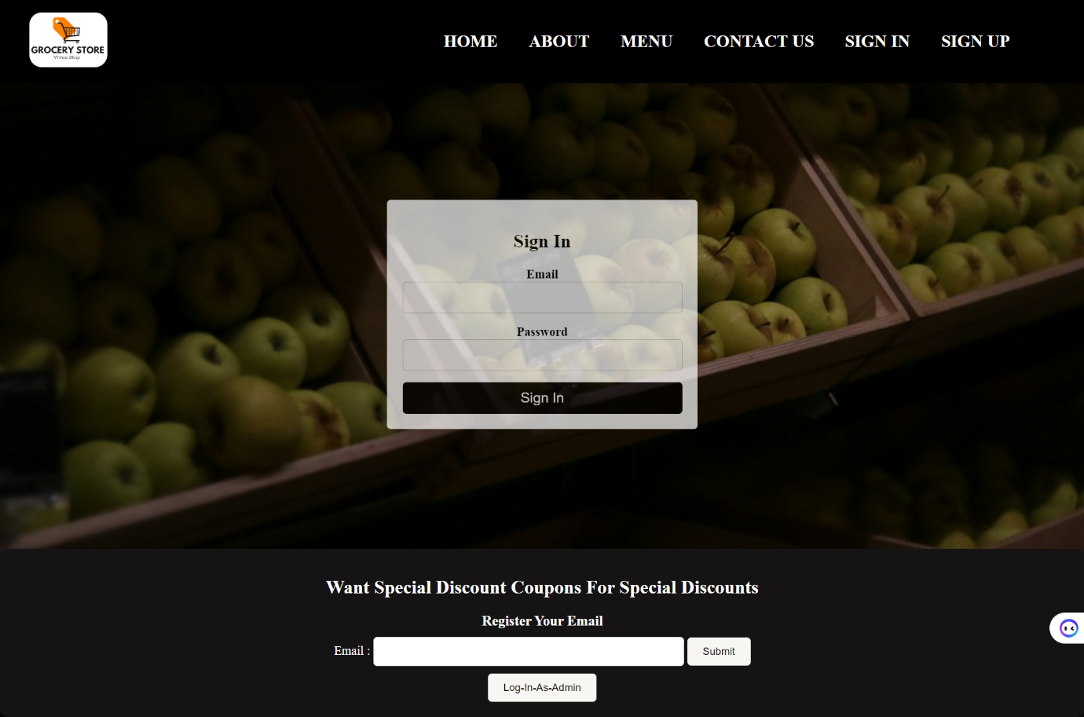This is sign up page that have various input fields and each field with a required validation and if a user has already made an id this form will throw an alert that user has already registered.

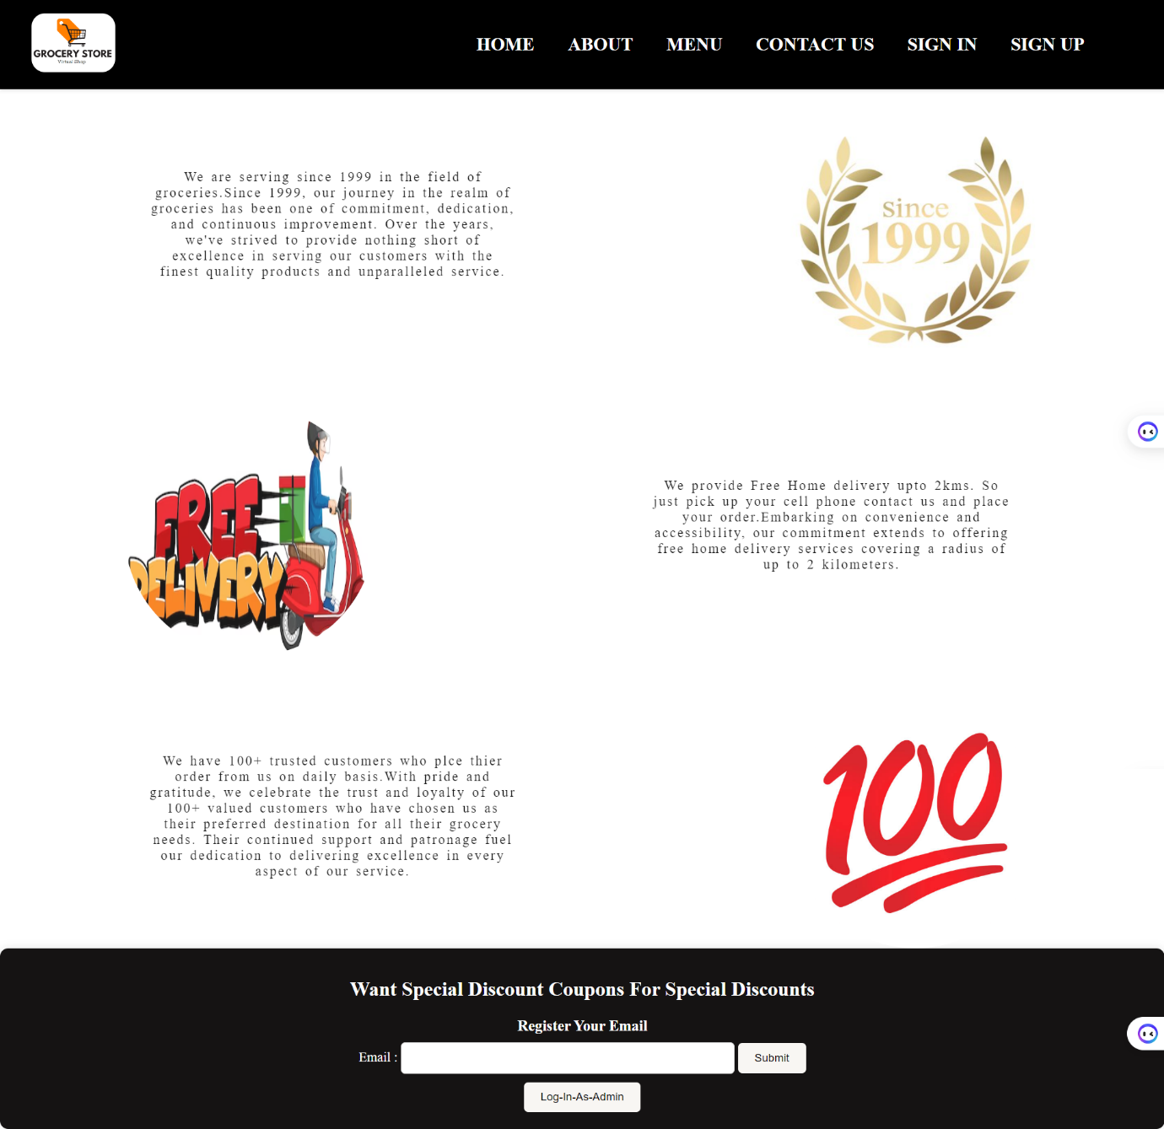After successful sign up the data gets store in database and website automatically redirects us to sign in page that asks username and password that also has required validation and if between any of them is empty it asks user to fill it and if user enter wrong password it alerts user that wrong password.

This is about us page that shows stores past.

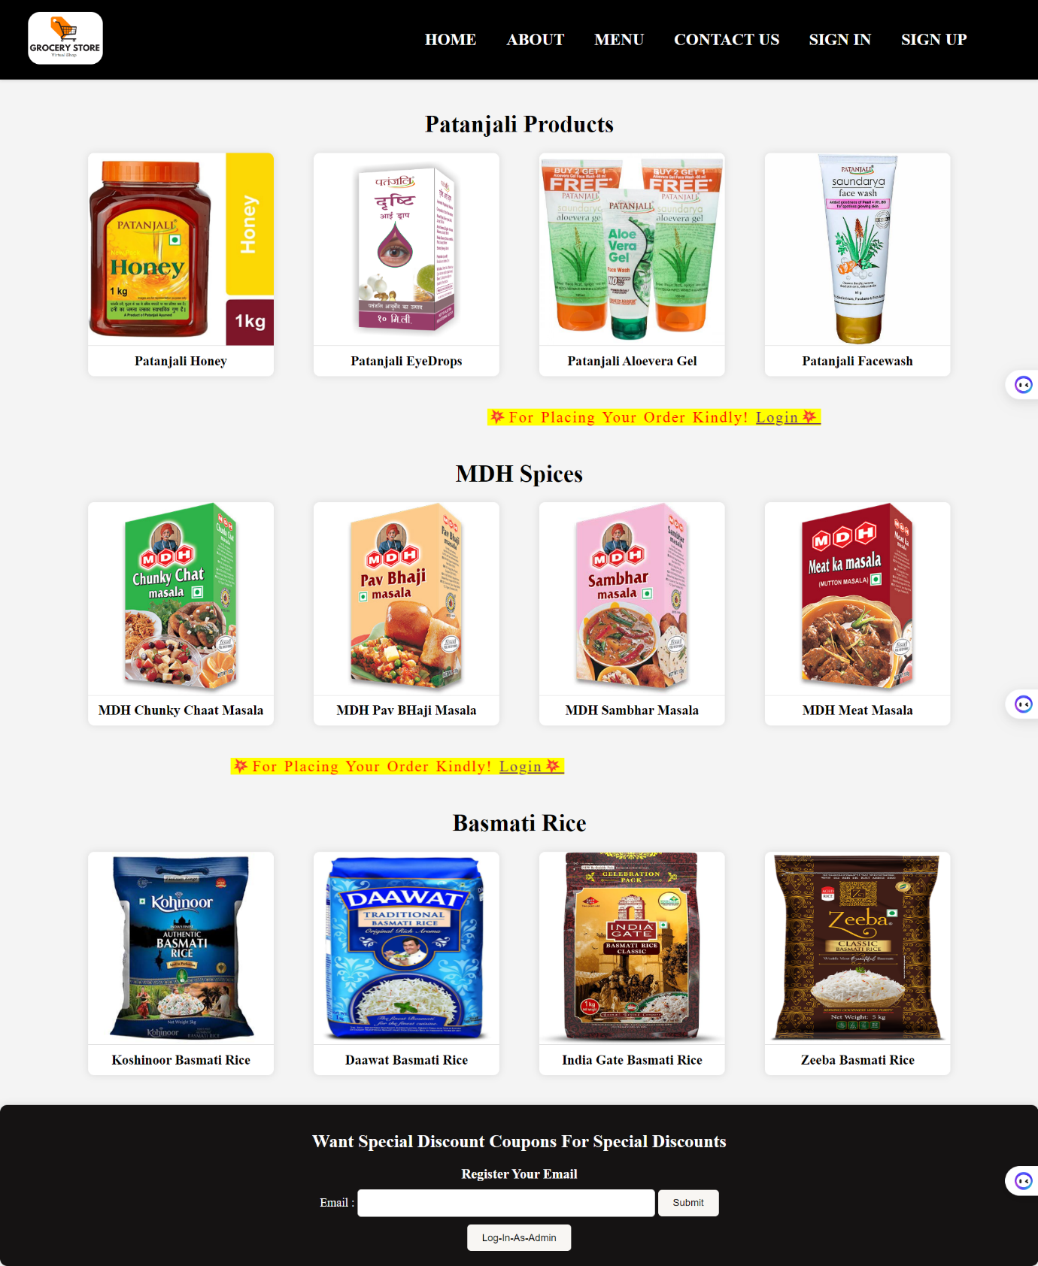

This is stores menu that shows what all items store does have and also shows an message that for ordering kindly login.

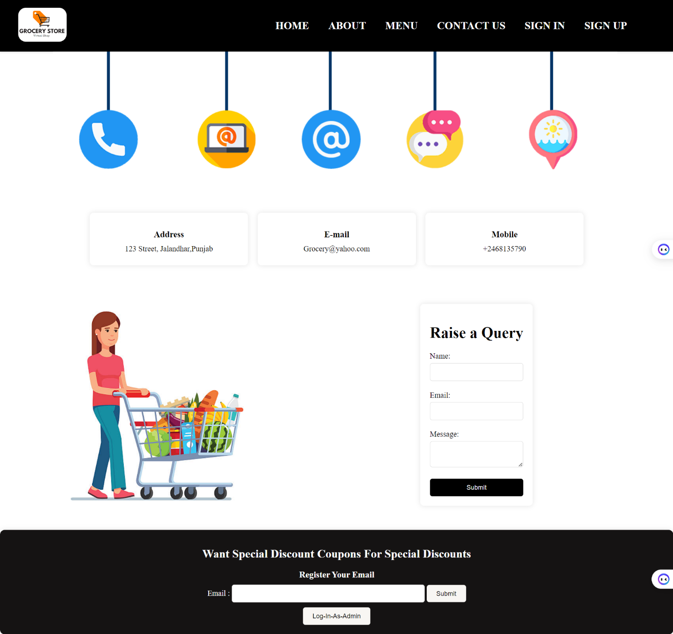

This is contact us page through which the user can raise a query and can directly contact with the owner.

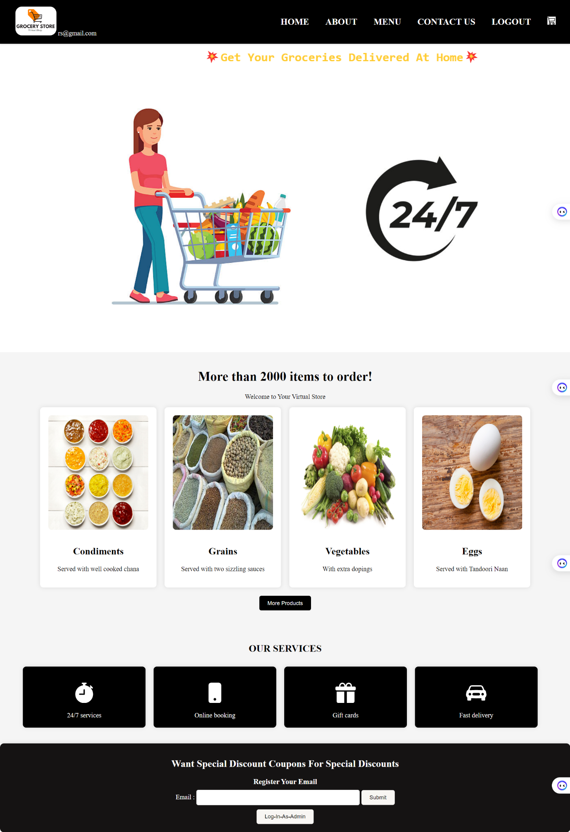**After Login**

After login the name of the user displays in the header along with logo and a cart button and logout is available after login.

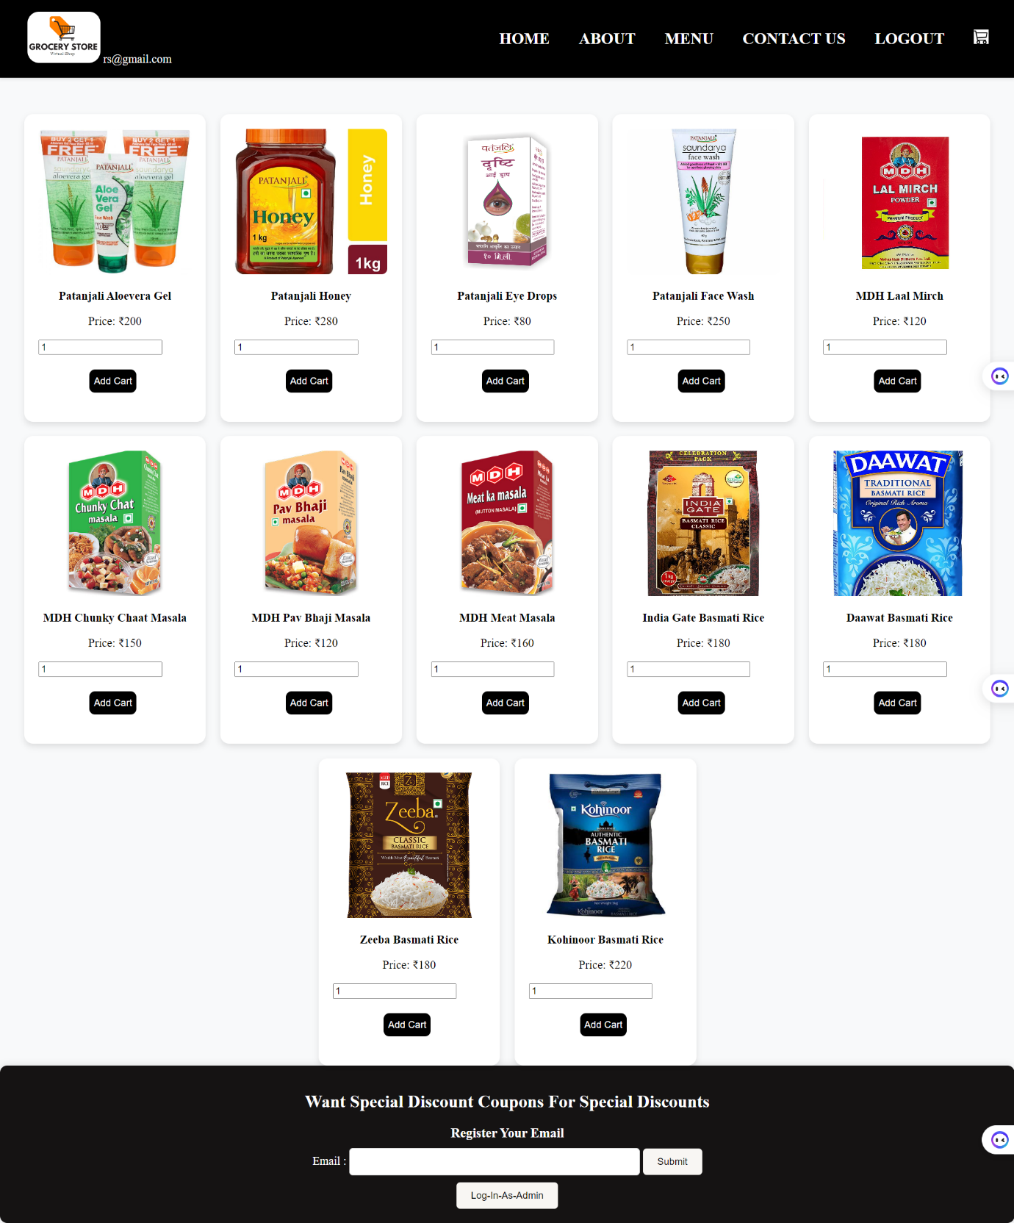

After login menu shows up like this and if user wants to buy something he or she can add it to cart.

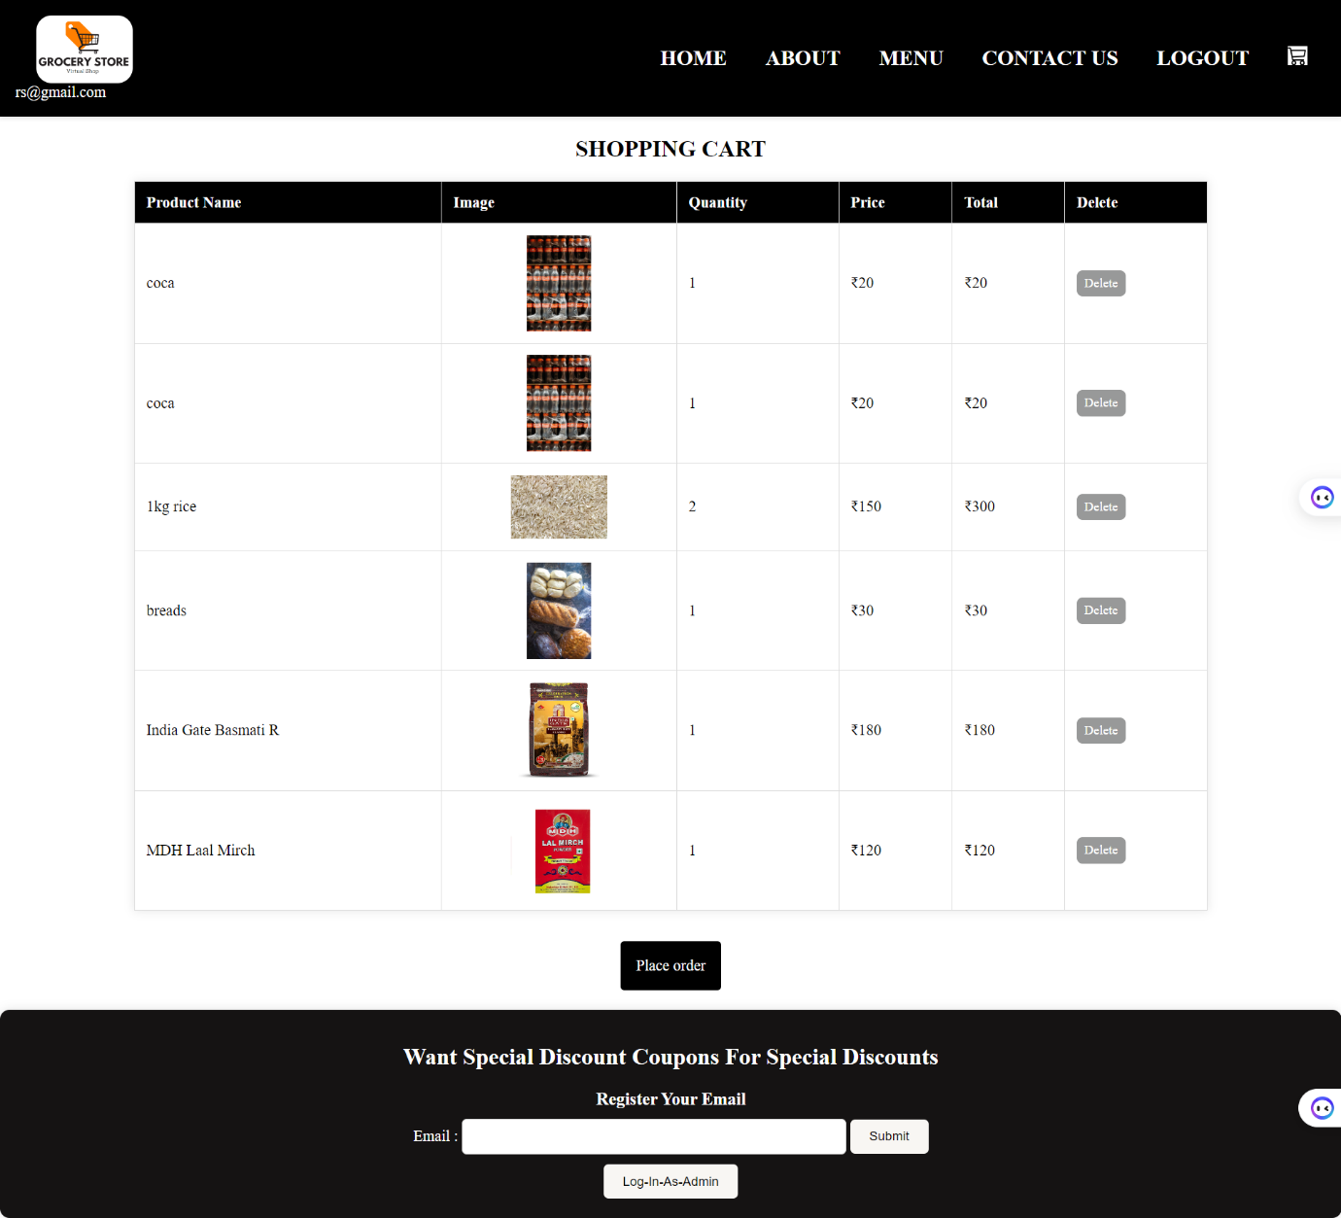

Cart shows up like this and reviews what all thins user has put into the cart and click on place order button.

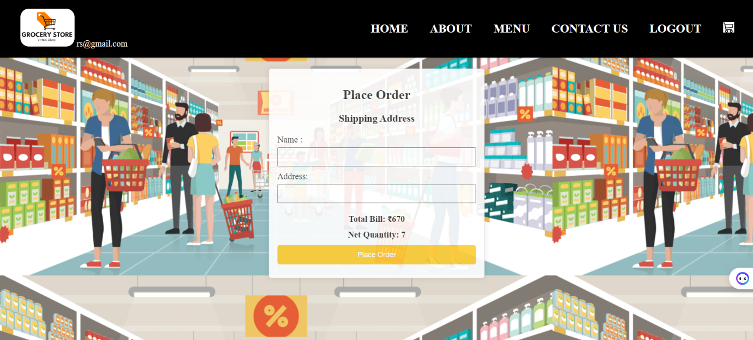after clicking on place order button it redirects to a new page and demands for name and delivery address .

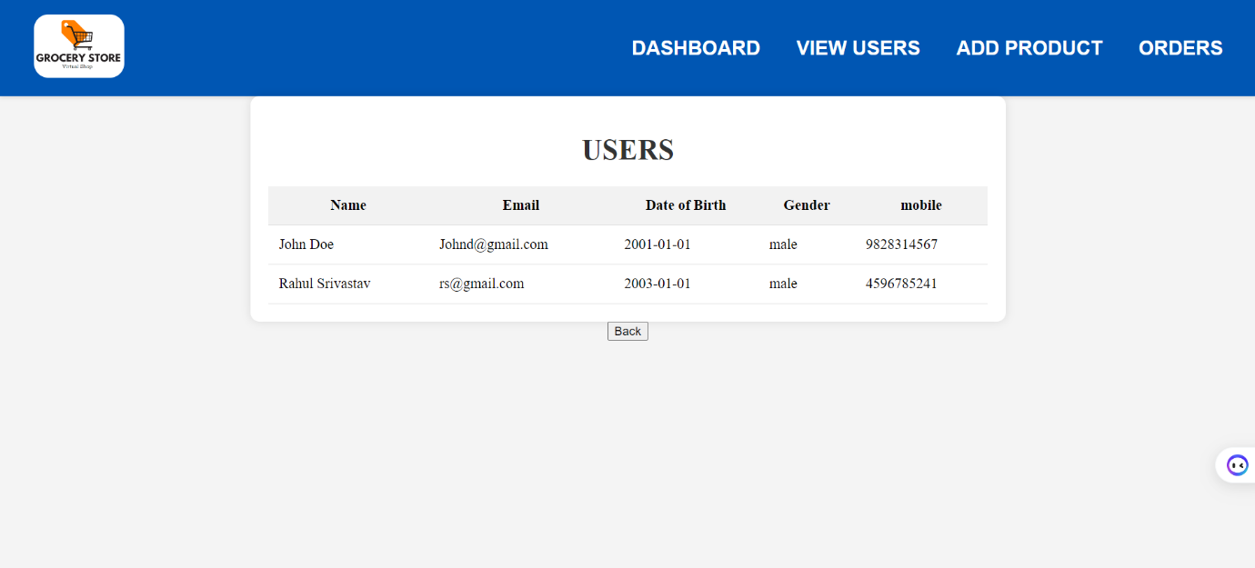**Admin**

Admin can view users that has logged in to the website.

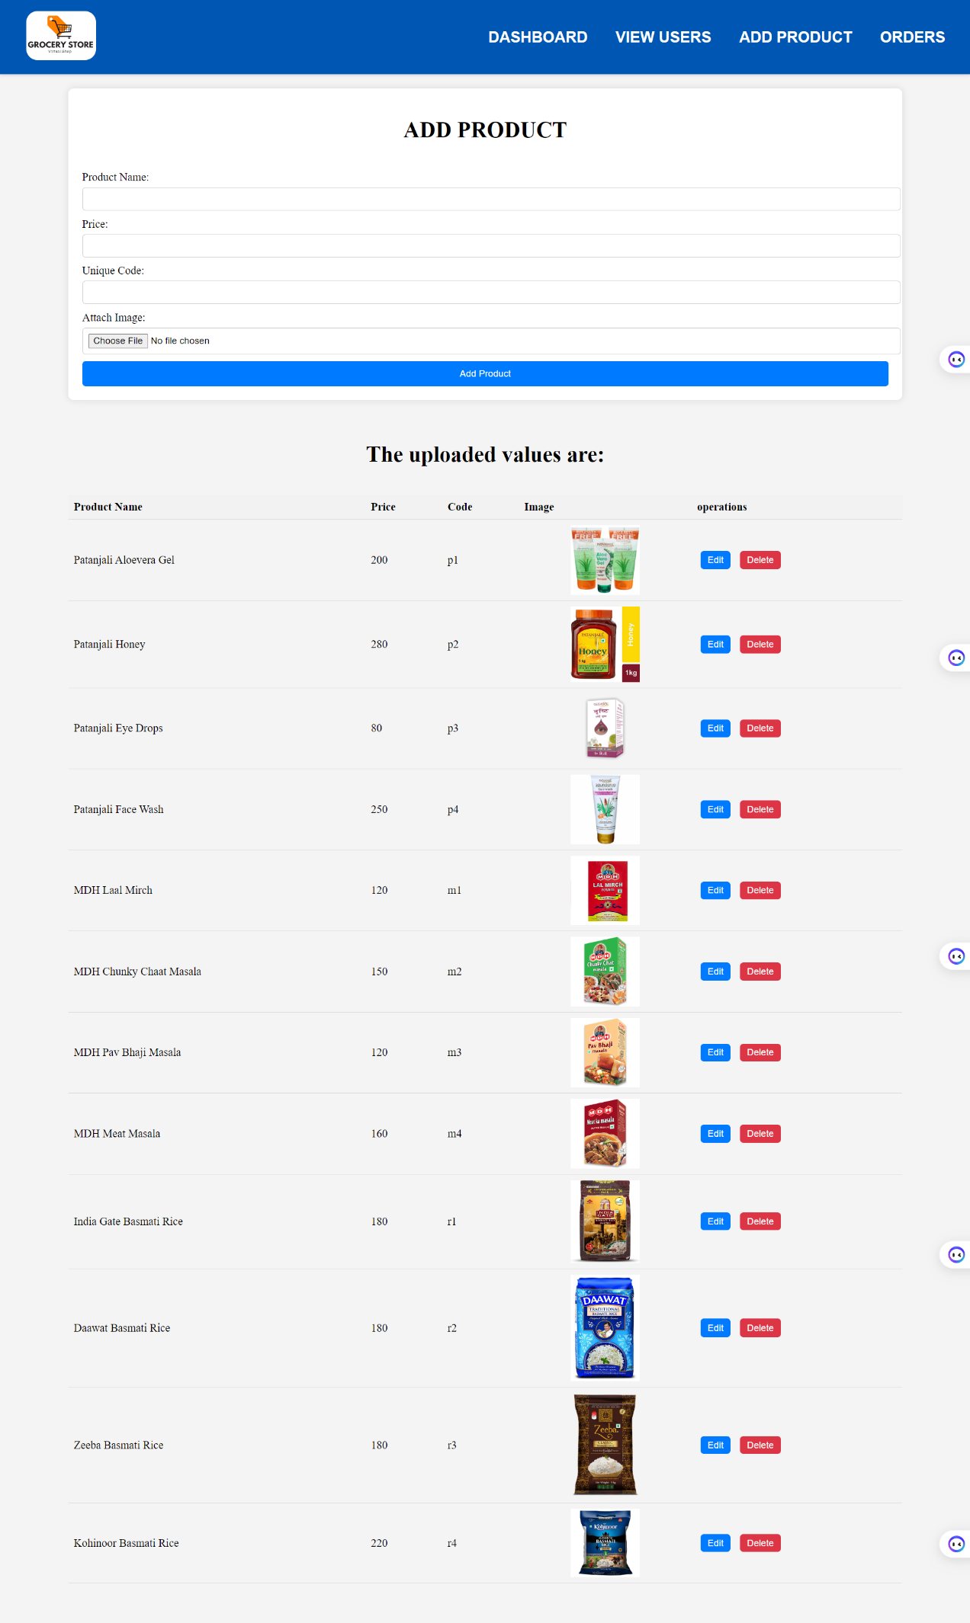

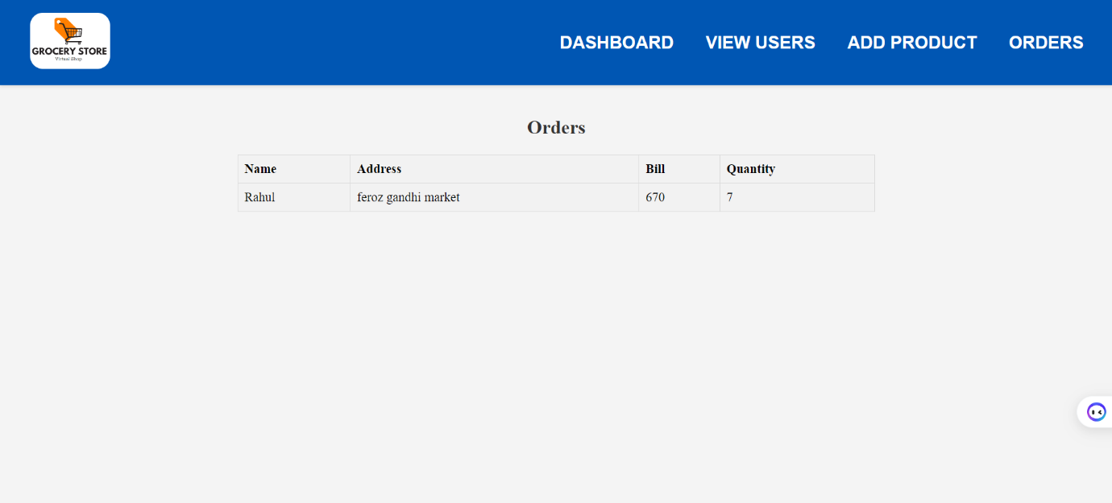Admin can add/edit/delete product.

Admin can also see the address of the delivery that user has mentioned.